Jibebe Internship 2022

# Progress report

Name: ADHO MAMO

## Tasks completed last week

* [#9] Circuit diagram of the robot car- The circuit diagram was drawn using the fritzing software.
* [#16] Definition of the path followed by the robot car- This is one of the missions of the project. The path followed by the tractor must be defined so that the robot can follow the correct path and also to ensure that the mapped area is well tilled.

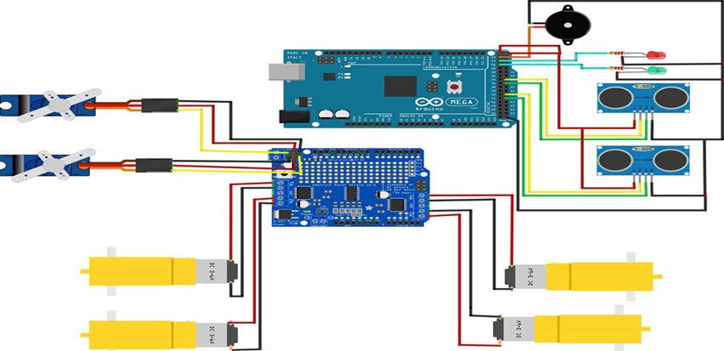

Figure 1Circuit diagram of the robot car.

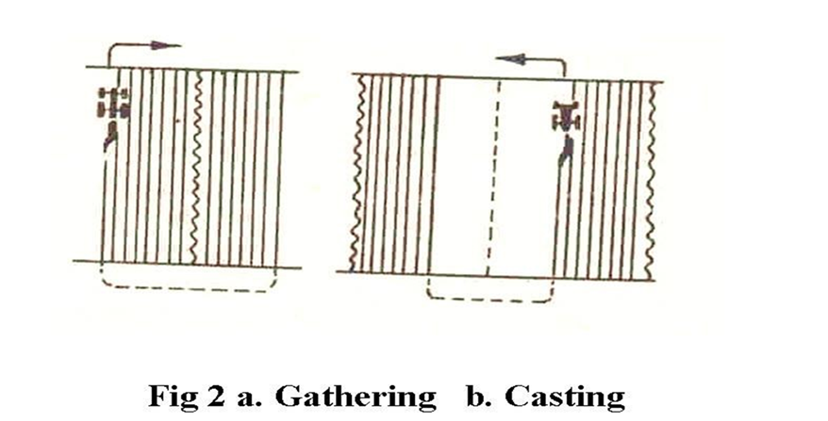

Figure 2 paths followed by the robot car.

**Gathering-** plough works round a strip of ploughed land.

**Casting-** plough works round a strip of un-ploughed land.

## Tasks in this week

* [#15] Redesign of the chassis drawing- Redesigning of the chasing drawing on the AutoCAD software is to be done so as to have dimension tolerance for good printing.
* [#22] Laser cutting of the chassis- Brief overview of the laser cutting machine and the Corel draw software was done. The design of the chassis drawing was imported to the Corel draw software and the laser cutting machine was used to cut out the chassis and its parts from the acrylic material.
* [#23] 3D design of the chassis and the motor mounts- designing of the chassis and the motors will be done using the AutoCAD software. This will be used to lock the motors to the chassis and also to join the bottom and the top chassis using fasteners.
* [#24] 3D printing of the motor mounts

## Timeline

|  |  |  |
| --- | --- | --- |
| Month | Intern week | Tasks |
| Jan |  |  |
| Week 1 | Identification of parts and drawing of the chassis diagram. |
| Week 2 | Circuit diagram and acquisition of parts. |
| Week 3 | Definition of the path to be followed by the robot car.  Laser cutting of the parts. |
| Feb | Week 4 |  |
| Week 5 |  |
| Week 6 |  |
| Week 7 |  |